**Engineering Notebook**

**Team 16 – Clear Path**

**09/12/2024** - Team 16s first meeting and talk with customer, Dr. Towhidnejad. Scrumwise and Github established to start adding to backlog and documentation for the project. Division of skills between team members like Scrum-Master, Software, Hardware, and documentation. Stand up meeting to discuss the proposed objectives from customer and first steps taken.

**09/24/2024** - Teams first day in LB 131 with the flight simulator. Below is some of the information we gathered.

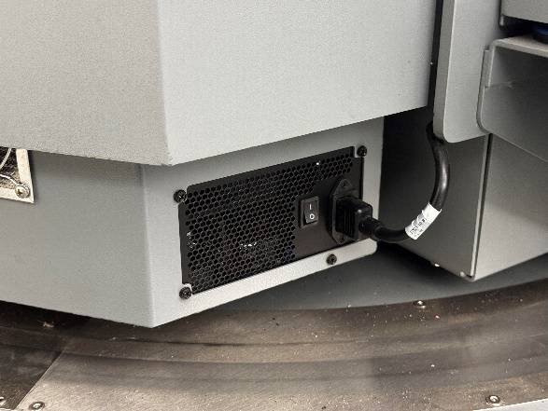

The white switch turns on the whole rig, and the smaller switch on the right side is now to turn the PC on.

There is a small red button below the seat on the right side, click the button one time for the green light to illuminate. Finally plug a wired keyboard into the hub on the right picture, follow the prompts on the screen and get to the home screen. From there we can use the wireless keyboard with mouse built in to navigate. We also uploaded any relevant text documents into our GitHub (<https://github.com/SadeedKhan555/ClearPath>).



We got some time in on the simulator to see the different function, and displays within X-Plane.

10/15/2024 - Replacing Emergency stop button, part was ordered a week in advance install was slowed due to hurricane and campus closure. Images for button install are below. In addition, the peer reviews were completed by team members along with the sprint review presentation.



10/22/2024 - United Briefing; No work done

10/24/24 – Team meeting with student previously in charge of flight sim to ask questions related to start-up and uploading/inserting data into Xplane. Installation of graphics drivers to flight sim computer to start running XPlane 12. Sprint 3 finished; Items on backlog rearranged to reflect future project progress.

* Sprint obectived accomplished:
  + Meeting with student in charge of sim